eLPF Online Tool

Table of Contents
Introduction 2
Understanding the eLPF Online tool 2
Registering your school for the eLPF online tool and administering your survey 3
Administering your survey 7
Prepare your staff to use the online tool 8
Who should take part? 8
Who has access to data in the eLPF/MMeLPF online tool? 11
Analysing the data 12

Introduction
The following sections are structured to support schools to use and gather data in relation to the e-Learning Planning Framework (eLPF) online survey. These guidelines outline the anticipated “workflow” for schools from identifying the need to undertake an e-learning review through to analysing the results of the eLPF survey online and planning next steps.

This tool is designed to be used as a component of your school-wide self review processes.

These guidelines will take you through the process step-by-step. A high level of technical knowledge is not required.

Further support material can be accessed through:
- Using the e-Learning Planning Frameworks group in the VLN
- Enabling eLearning website

For help email: elpf@vln.school.nz

Understanding the eLPF Online tool
The e-Learning Planning Framework (eLPF/MMeLPF) is a tool to help schools and teachers reflect on and evaluate their e-learning capability. It is intended to support the regular self-review and subsequent improvement of e-learning skills and knowledge, in ways that reflect our bicultural heritage within a multicultural context. The dimensions within the eLPF/MMeLPF are derived from a synthesis of international research and from a range of e-capability frameworks; while the phases draw on professional learning frameworks such as Concerns-Based Adoption Model (CBAM). The central thrust of the eLPF/MMeLPF is that all the dimensions all need to be “in play” if a school is to sustain its e-capability development over time and in ways that reflect effective practice for educators and outcomes for learners.
The framework provides schools and teachers with:
- a self-review tool for schools to gather evidence about practice
- a “road map” for building e-learning capability
- a tool to evaluate the effectiveness of e-learning programmes
- resources and services to support schools as they build capability.

Registering your school for the eLPF online tool and administering your survey
One person (principal or e-leader) should be designated as the administrator of the tool. This person will register their school for the eLPF online tool and administer the survey.

1. Go to: elpf.vln.school.nz. Click on the button indicated, “I need to register my school for the eLPF Online Tool.”
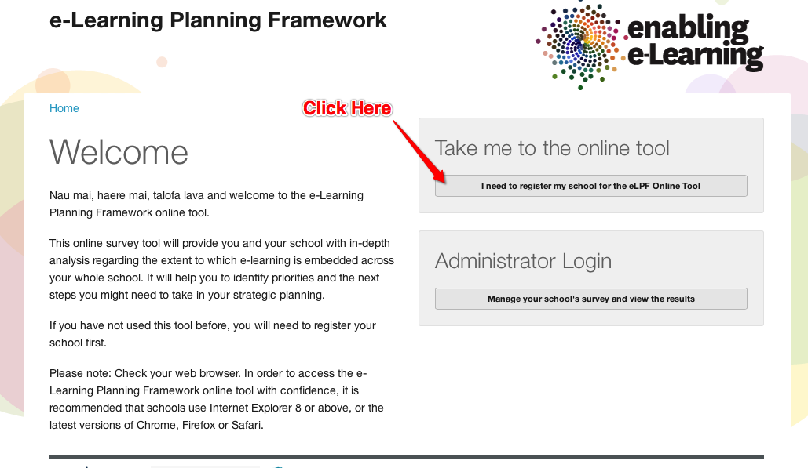

2. Type the name of your school. The list of schools will automatically shorten based on the letters/words you type. This will work for any part of your school name. Click on your school name to begin registering your school.
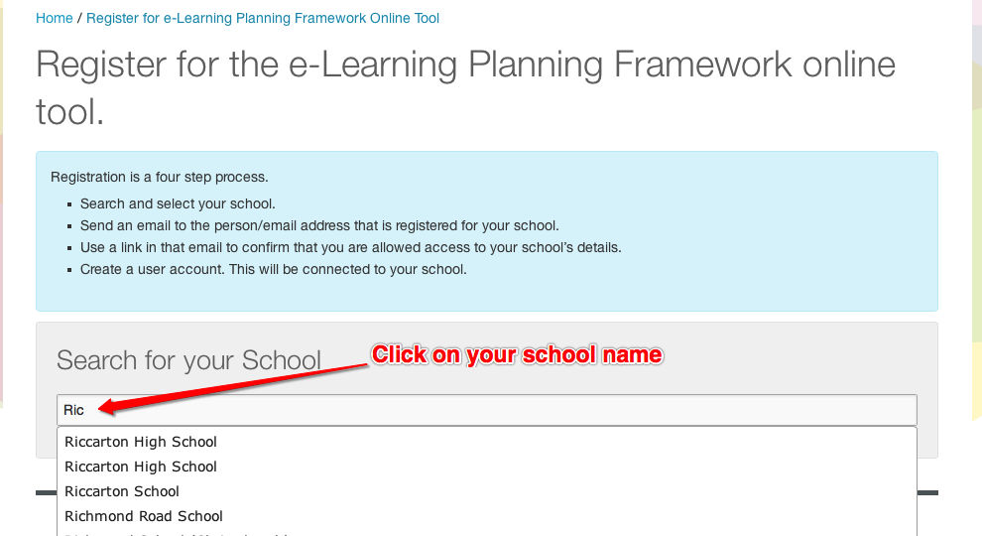

3. Click on Request ELPF Access. This will send an email to your school’s administration email address held by the MoE. If the email does not arrive you may need to contact your network administrator as it may have been sent to an inactive email address or filtered by your school spam filtering. If the email still can not be located contact mailto:elpf@vln.school.nz.
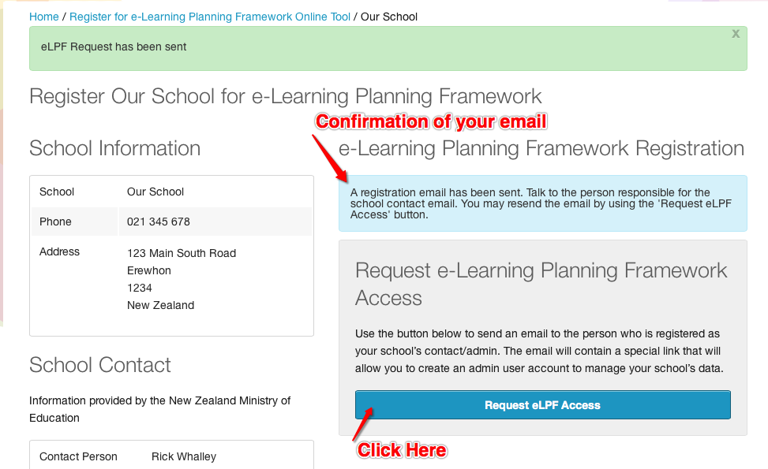

4. An email is sent to your school email address (this is the address provided to the Ministry of Education and can be checked on the TKI schools page). The screenshot below shows the email. Click on the link indicated in the email to continue with the registration process.
Clicking on this link will take you back to the eLPF Online Tool website in your browser.

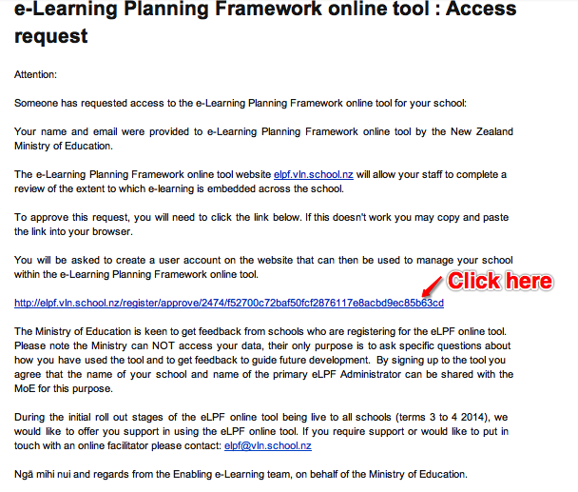

5. This screenshot shows the eLPF Online tool email address confirmation screen. Please complete your details in the appropriate boxes. Choose a username and password and record these for future reference.
You may find your preferred username is not available. In this case you will need to choose a different one.
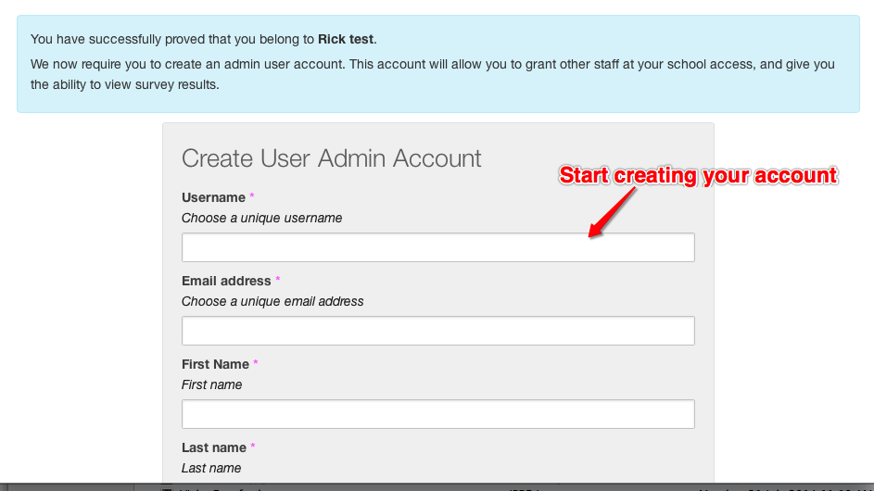

6. Your account is set up with your school information. A survey is setup and you are ready to begin using the tool. Help is available at: elpf@vln.school.nz.

Administering your survey
Process for survey administrator to follow:
- Log in. Information and instructions are included on each tab. Each of the blue tabs enable you to complete a different function during the administration of the survey, examining the results and (if needed) managing survey responses and sharing the results. The tab names indicate these.
- Decide specifically who will be included in which groups for the administration of the survey. These are: teacher, leader, middle management, student and whānau.
- Go to the send survey tab: From this page, you can choose how to administer your survey. You can choose one of three options. We recommend the first option:
Option 1: Assign users to specific roles and invite them to take the survey based on these roles: This allows you to allocate staff roles in advance. Clicking the appropriate red button opens your email client and automatically generates an email which contains a link that you then send to specific staff members. This option, with its clearly identified groups for the different roles, will give you the most precise set of results as you will be clear who is in each group based on the url you sent them via email.
Option 2: Send a generic link to all users: Clicking the blue button will automatically open your email client and generate an email which contains a link that you can send via email to all those who you wish to take the survey. Users will then select the most appropriate role for themselves as the first step of completing the survey.
Option 3: Copy and paste the direct urls supplied at the bottom of the page into your own emails and send them out to different staff members. This enables you to personalise the emails for specific users or groups of users. If you choose this option be careful to note you can choose a global url (as in option 2) or role-specific url’s ( as in option 1).

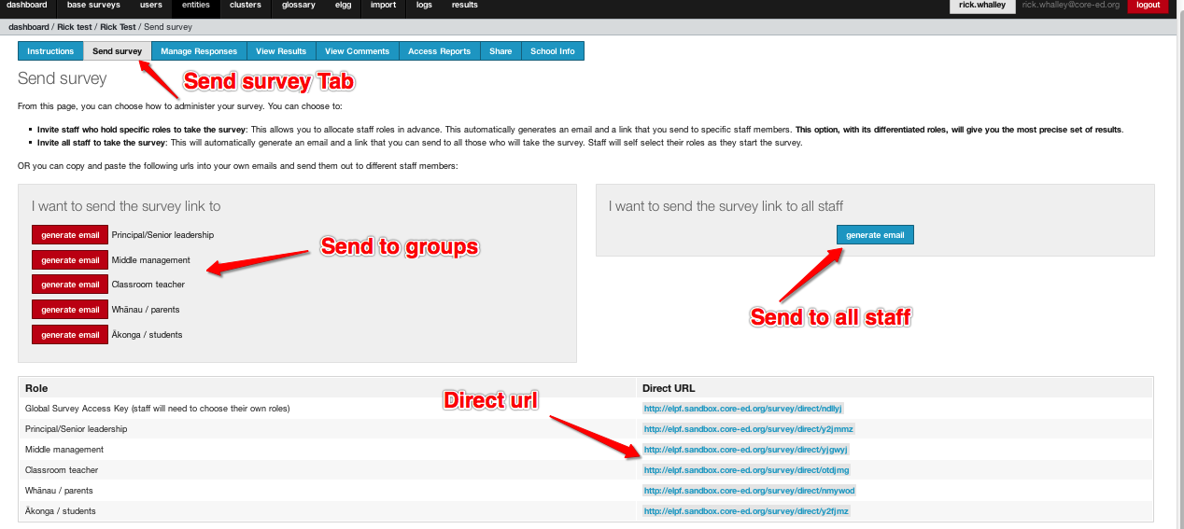

Prepare your staff to use the online tool
Staff, students and families provide the best information when they use the online tool when they fully and clearly understand the purpose and structure of the survey.

Who should take part?
The results are likely to be more accurate and truly representative of the school position if everybody completes the review, as opposed to a sample group of staff.
It is possible to have a staged roll-out of the review. For example, the leadership could complete it first and then see how aligned they are in their responses. Then the survey is extended to the rest of the staff, students and whānau. This may highlight areas where different user groups may require more intensive scaffolding in order to be able to fully access the language and concepts they will come across in the surveys themselves.

During the administration of the surveys it is important that the participants understand the following:
- The survey is anonymous. Encourage participants to be as honest as they can in their responses. NOTE: If one user group is very small it may not be possible to guarantee anonymity - you may prefer to manage the review a different way.
- It is important for participants to email their PIN number when they login for the first time. This is to enable them to return to the survey and access their own data. The PIN must be used every time they go back into their survey, or a new survey will be generated and this can obviously impact the results.
- The survey takes approximately 40 minutes to complete, depending on how many comments they write.
- If it feels repetitive it's because there are two questions for each aspect, one inviting their personal view, another inviting their view on the school as a whole. Having both perspectives enables staff to reflect the fact that their personal position may be different from the rest of the school. For example, they may utilise mobile devices effectively in their programmes but realise others in the school do not.
- Some statements look like they are asking for two things. This is because the statements are derived from most developed phase of the framework, and effective review is often part of this “highest level”. Users need to consider the extent to which they agree that this is an accurate description of the current position of the school or themselves, rather than right/wrong.
- Encourage staff to put in comments, seeking clarification, or in terms of qualifying their thinking. Schools who have completed the survey in the past have reported the comments as being some of the most useful information they have received. Any areas of strong feeling or particularly high or low assessments should have a comment if possible.
- In terms of test validity, the survey should be completed in a single time period. It can be paused if necessary. The link and PIN number emailed when beginning the survey are the way to access the survey again.
- The questions range across all five dimensions in random order.
Instructions for taking the survey

1. Use to the url you received from your survey administrator. To begin the survey, click the blue Begin button.
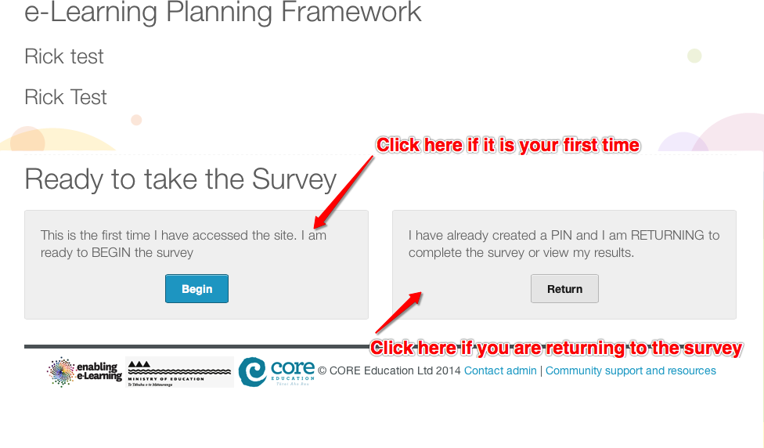

2. Email the PIN to yourself. Clicking on the blue button will generate your PIN and open your email programme with the direct link to your survey. Participants must complete this first step! NOTE: Administrator, ALWAYS emphasise the importance of this step with all participants.
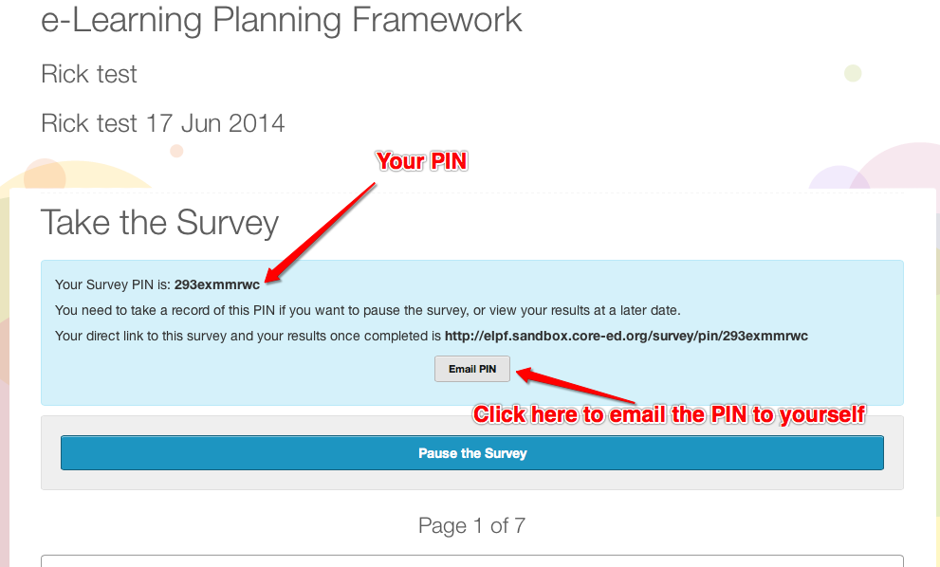

3. To complete the survey questions, position the slider at the level you agree with the statements. If you agree that the statement is completely true, position the slider completely to the right. If you disagree completely, position the slider completely to the left.
The slider will appear when you click in the bar to the right of the statement above the add comment button.
Clicking on the add comment button opens a text box. Comments do not have a word limit, so can be any length. Leave comments where possible to enhance the information gathered.
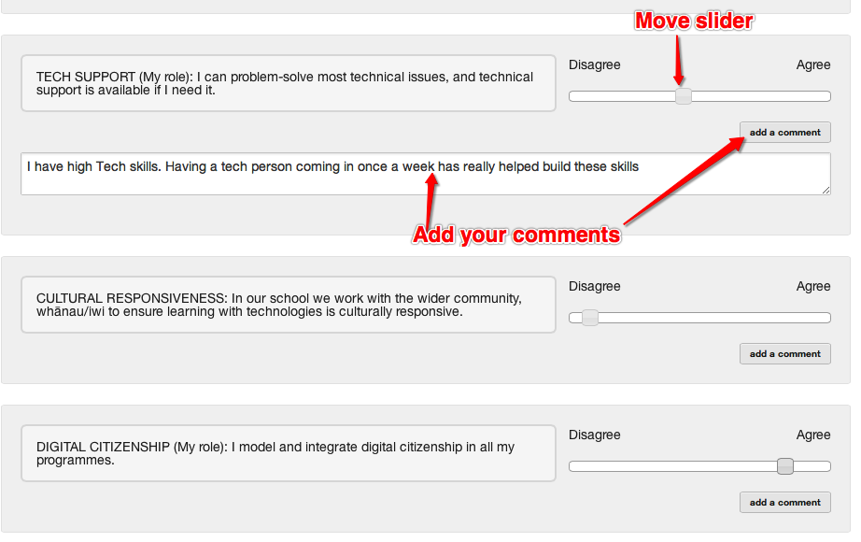

4. Click Submit when finished! If this is not done the survey is not included in the aggregated results. You can return to your survey to complete this step if necessary via the direct url and your PIN number.
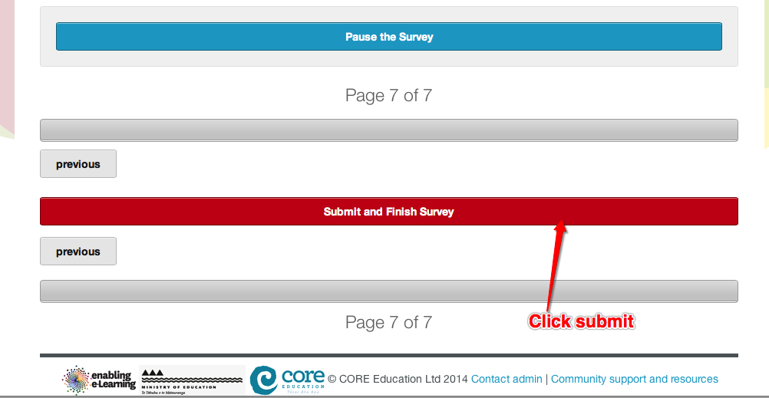

Who has access to data in the eLPF/MMeLPF online tool?
The survey administrator is the only person who can access the online eLPF online tool data. To share access to the data the survey administrator can:
  - add another “Administrator” through the school dashboard
  - send the sharing url, this is sent from the Share tab in the Administration interface. The data that is shared here is only the aggregated information from the ‘View Results’ tab.
The time period for sharing can be set for anything from one hour to one month. Sharing can be revoked at any time by “resharing” via this tab. This breaks all earlier sharing urls.
Both of these things require specific actions from the school administrator for the tool. Schools have complete control over their data.
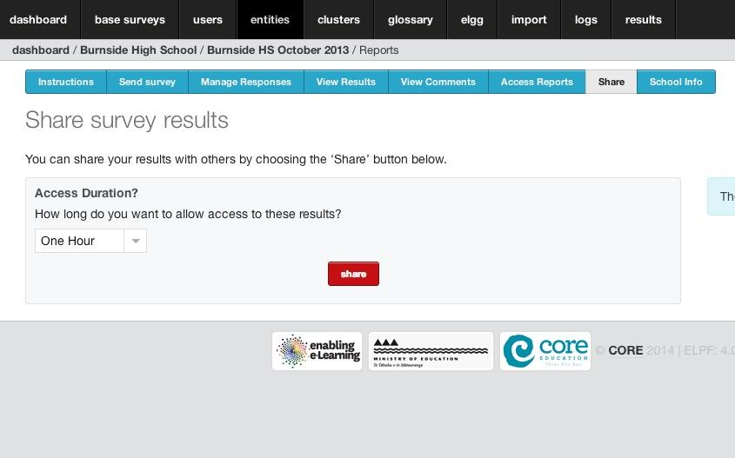

Analysing the data
Once the survey has been completed, the school survey administrator can access the survey results and reports to print and export.
Note it is advised you view the results online first, decide on priority areas to analyse more deeply BEFORE you print. The report can be several pages.
Interpreting the data might be a facilitated process with the leadership team, or the process might involve the whole school or groups from across the school, BoT, or wider community.
Questions you may wish to consider:
- Which dimensions and elements look more/less developed – and what factors might explain this?
- Looking across those elements that are MORE developed and synthesizing them. What links these different elements? Why are we strong in those areas? This might be an area to consolidate and build on – these particular elements might be the ones to print off, share and celebrate as a way to build on the expertise within the school staff.
- Looking across those elements that are LESS developed. What links these different elements? Why are we not as strong in those areas? For example, you might notice several less developed areas might be linked by lack of cultural responsiveness. Can you tell a story about why this might be? – develop an understanding of how these might be sensibly integrated and combined in a single, synthesised priority for the action plan. These elements might be the ones to print off share and explore further as next steps with the whole staff (rather than printing off and sharing the entire report).
Further support with eLPF data analysis

